Anomalia no GIT via console

Com a chegada das centenas de novos alunos via Bootcamp Santander, ocorreu uma enxurrada de reclamações e pedidos de ajuda no Fórum da Digital Innovaton One, conforme reportei no Jira, chamada **DIOS-3283**

Acredito que tenha ocorrido algum bug na implementação e ou instalação, pois são dezenas de pedidos de ajuda, acredito que a melhor solução, seria a criação de um vídeo-aula explicando estas dificuldades de configuração.

Efetuei um apanhado no fórum em busca dos problemas listados, recuei até 26 de Junho, copiei o link e anexei com print-screen neste documento.

# Minha contribuição

Procurei auxiliar respondendo no próprio pedido de ajuda, porém são tantos que acabei publicando este post.

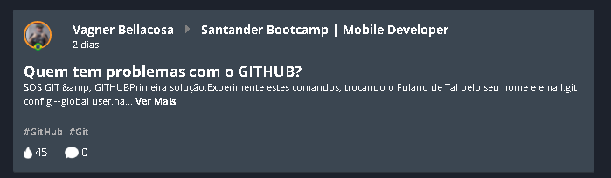

<https://web.digitalinnovation.one/topics/quem-tem-problemas-com-o-github?back=/home>

O Thiago Oliveira também auxiliou criando um post com a soluçao

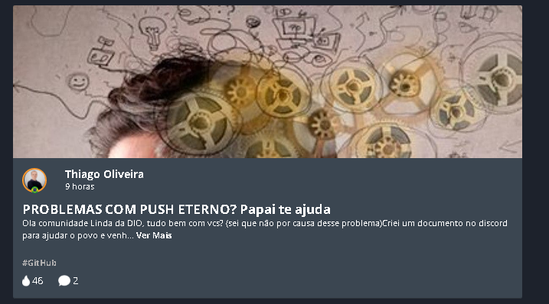

<https://web.digitalinnovation.one/articles/problemas-com-push-eterno-papai-te-ajuda?back=/home>

# Bug e problemas de configuração GITHUB

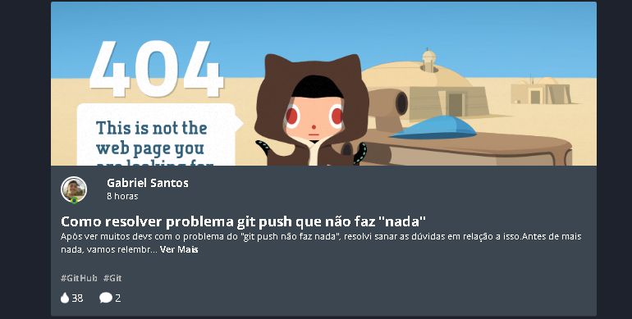

<https://web.digitalinnovation.one/articles/como-resolver-problema-git-push-que-nao-faz-nada?back=/home>

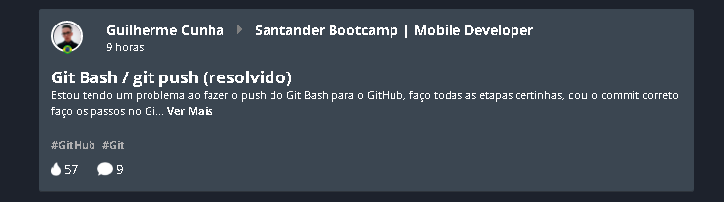

<https://web.digitalinnovation.one/topics/git-bash-git-push?back=/home>

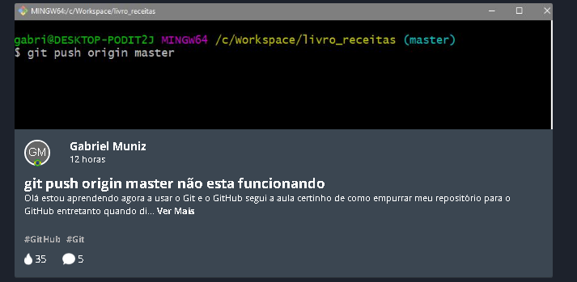

<https://web.digitalinnovation.one/articles/git-push-origin-master-nao-esta-funcionando?back=/home>

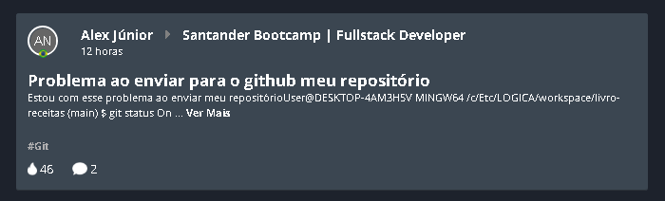

<https://web.digitalinnovation.one/topics/problema-ao-enviar-para-o-github-meu-repositorio?back=/home>

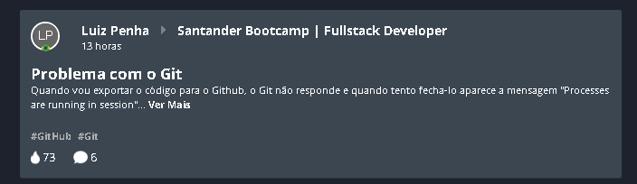

<https://web.digitalinnovation.one/topics/problema-com-o-git-1?back=/home>

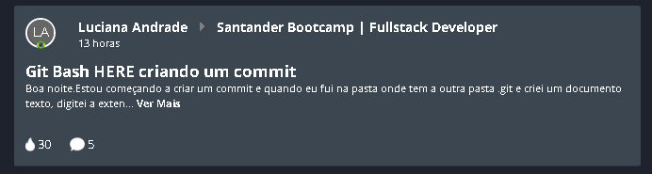

<https://web.digitalinnovation.one/topics/git-bash-here-criando-um-commit?back=/home>

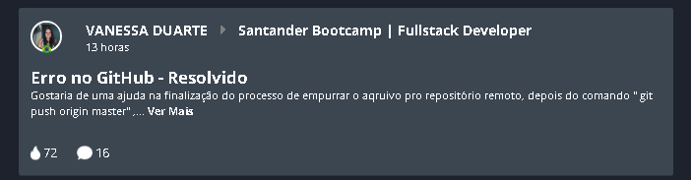

<https://web.digitalinnovation.one/topics/erro-no-github?back=/home>

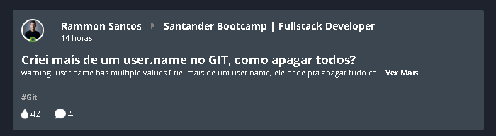

<https://web.digitalinnovation.one/topics/criei-mais-de-um-username-no-git-como-apagar-todos?back=/home>

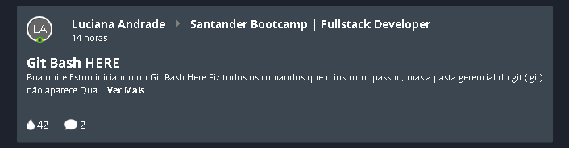

<https://web.digitalinnovation.one/topics/git-bash-here-3?back=/home>

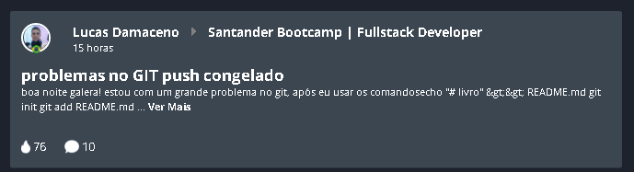

<https://web.digitalinnovation.one/topics/problemas-no-git-push-congelado?back=/home>

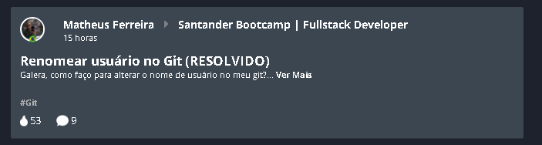

<https://web.digitalinnovation.one/topics/renomear-usuario-no-git?back=/home>

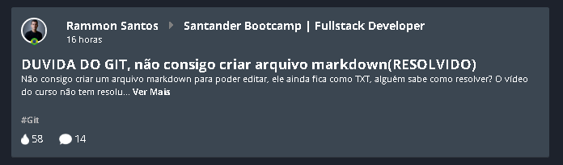

<https://web.digitalinnovation.one/topics/duvida-do-git?back=/home>

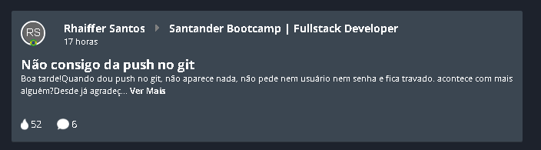

<https://web.digitalinnovation.one/topics/nao-consigo-da-push-no-git?back=/home>

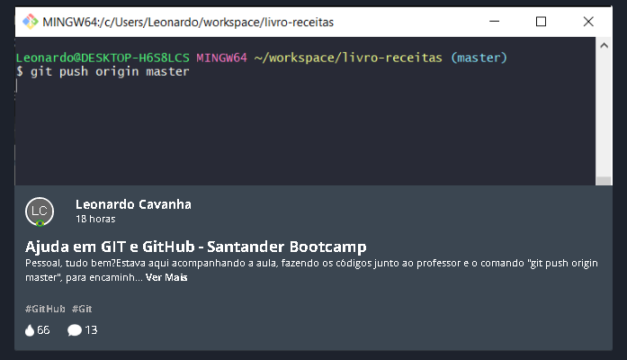

<https://web.digitalinnovation.one/articles/ajuda-em-git-e-github-santander-bootcamp?back=/home>

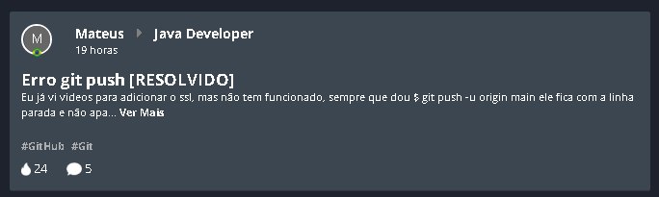

<https://web.digitalinnovation.one/topics/erro-git-push?back=/home>



<https://web.digitalinnovation.one/topics/github-duvida?back=/home>

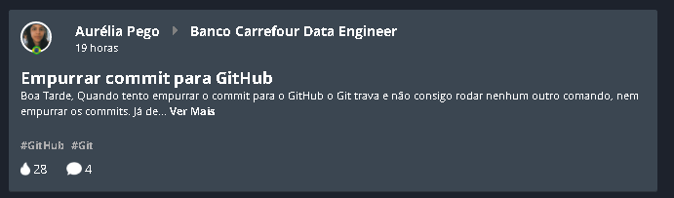

<https://web.digitalinnovation.one/topics/empurrar-commit-para-github?back=/home>

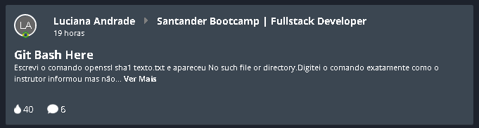

<https://web.digitalinnovation.one/topics/git-bash-here-1?back=/home>

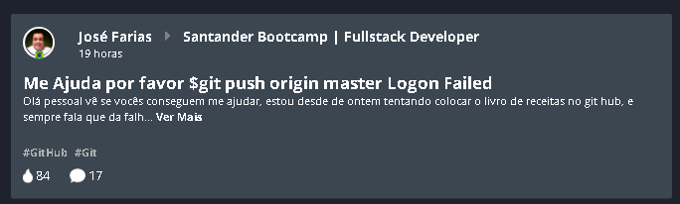

<https://web.digitalinnovation.one/topics/me-ajuda-por-favor-git-push-origin-master-logon-failed?back=/home>

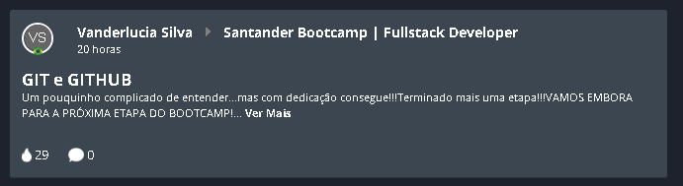

<https://web.digitalinnovation.one/topics/git-e-github-5?back=/home>

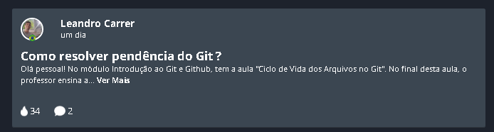

<https://web.digitalinnovation.one/articles/como-resolver-pendencia-do-git?back=/home>

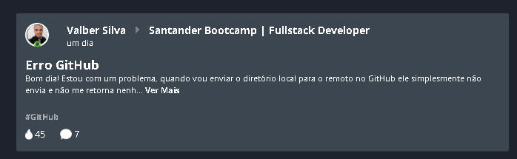

<https://web.digitalinnovation.one/topics/erro-github?back=/home>

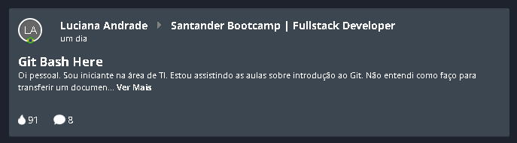

<https://web.digitalinnovation.one/topics/git-bash-here?back=/home>

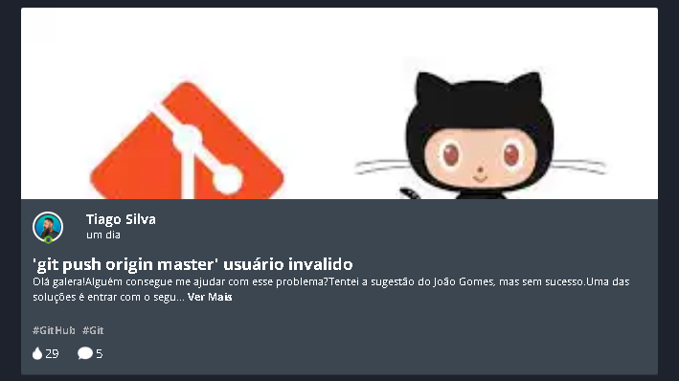

<https://web.digitalinnovation.one/articles/git-push-origin-master-usuario-invalido?back=/home>

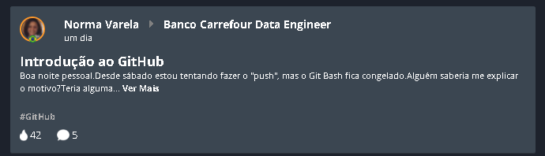

[**https://web.digitalinnovation.one/topics/introducao-ao-github-1?back=/home**](https://web.digitalinnovation.one/topics/introducao-ao-github-1?back=/home)

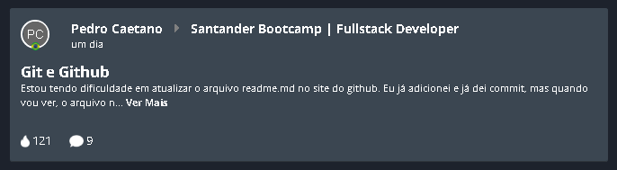

[**https://web.digitalinnovation.one/topics/git-e-github-4?back=/home**](https://web.digitalinnovation.one/topics/git-e-github-4?back=/home)

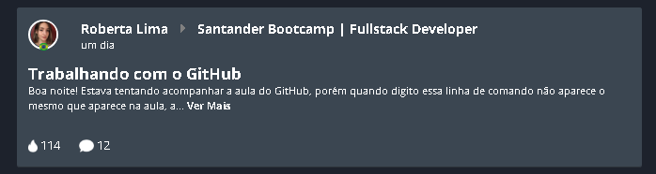

[**https://web.digitalinnovation.one/topics/trabalhando-com-o-github?back=/home**](https://web.digitalinnovation.one/topics/trabalhando-com-o-github?back=/home)

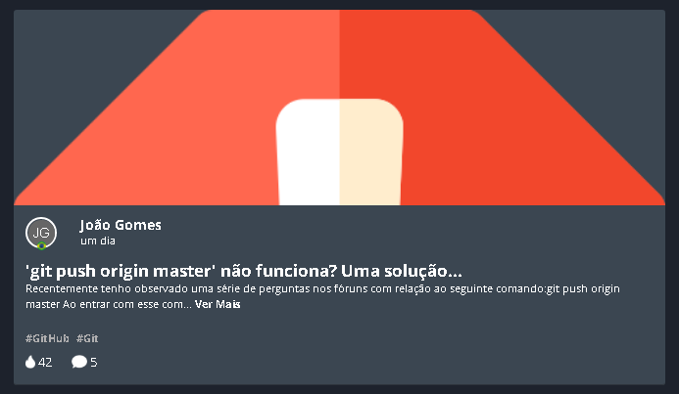

[**https://web.digitalinnovation.one/articles/git-push-origin-master-nao-funciona-uma-solucao?back=/home**](https://web.digitalinnovation.one/articles/git-push-origin-master-nao-funciona-uma-solucao?back=/home)

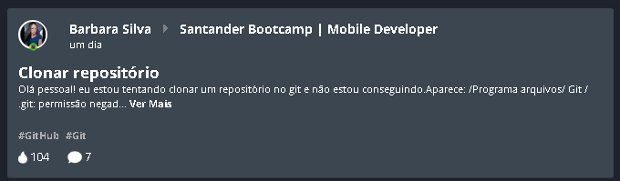

[**https://web.digitalinnovation.one/topics/clonar-repositorio?back=/home**](https://web.digitalinnovation.one/topics/clonar-repositorio?back=/home)

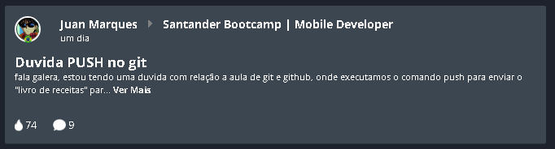

[**https://web.digitalinnovation.one/topics/duvida-push-no-git?back=/home**](https://web.digitalinnovation.one/topics/duvida-push-no-git?back=/home)

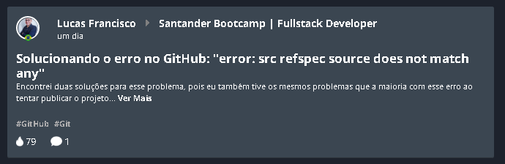

[**https://web.digitalinnovation.one/topics/solucionando-o-erro-no-github-error-src-refspec-source-does-not-match-any?back=/home**](https://web.digitalinnovation.one/topics/solucionando-o-erro-no-github-error-src-refspec-source-does-not-match-any?back=/home)

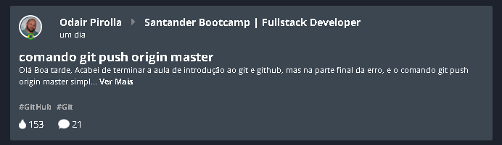

<https://web.digitalinnovation.one/topics/comando-git-push-origin-master?back=/home>

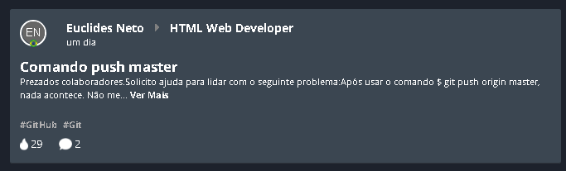

<https://web.digitalinnovation.one/topics/comando-push-master?back=/home>

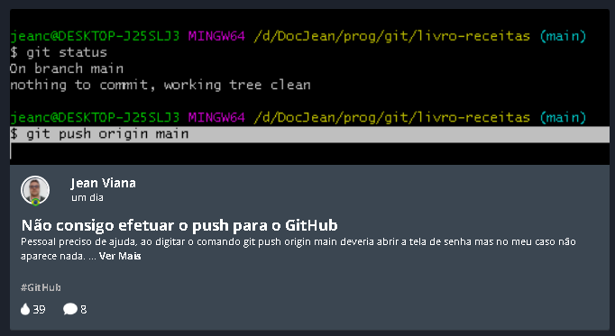

<https://web.digitalinnovation.one/articles/nao-consigo-efetuar-o-push-para-o-github?back=/home>

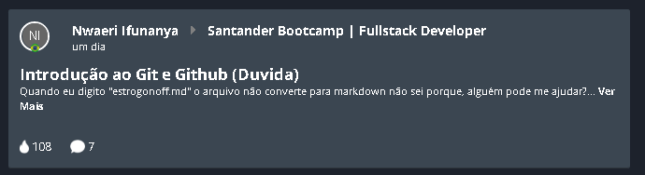

<https://web.digitalinnovation.one/topics/introducao-ao-git-e-github-3?back=/home>

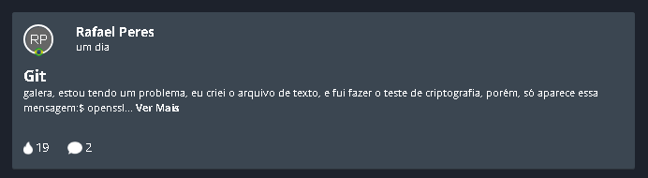

<https://web.digitalinnovation.one/articles/guit?back=/home>

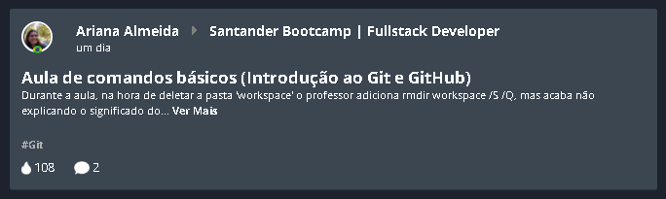

<https://web.digitalinnovation.one/topics/aula-de-comandos-basicos-introducao-ao-git-e-github?back=/home>

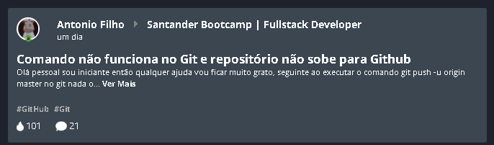

<https://web.digitalinnovation.one/topics/comando-nao-funciona-no-git-e-repositorio-nao-sobe-para-github?back=/home>

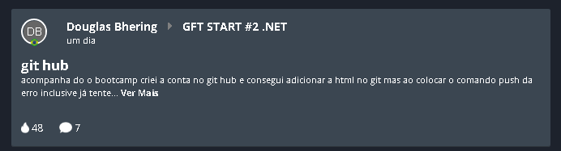

<https://web.digitalinnovation.one/topics/git-hub-1?back=/home>

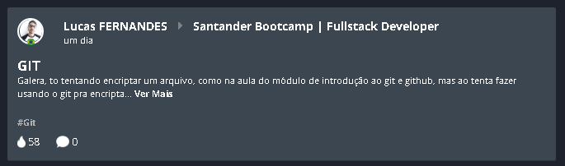

<https://web.digitalinnovation.one/topics/git-6?back=/home>

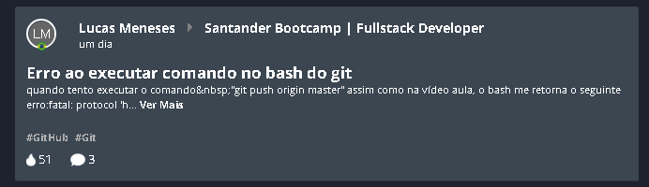

<https://web.digitalinnovation.one/topics/erro-ao-executar-comando-no-bash-do-git?back=/home>

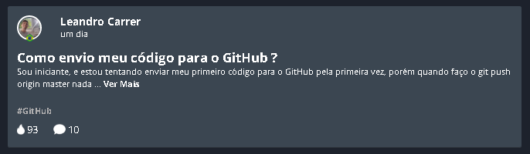

<https://web.digitalinnovation.one/articles/como-envio-meu-codigo-para-o-github?back=/home>

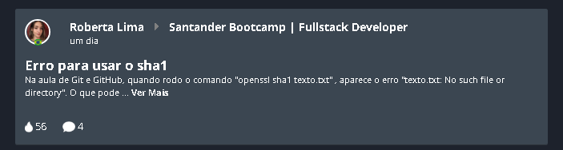

<https://web.digitalinnovation.one/topics/erro-para-usar-o-sha1?back=/home>

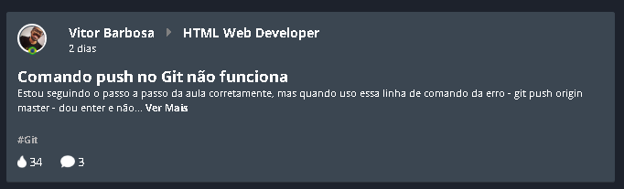

<https://web.digitalinnovation.one/topics/comando-push-no-git-nao-funciona?back=/home>

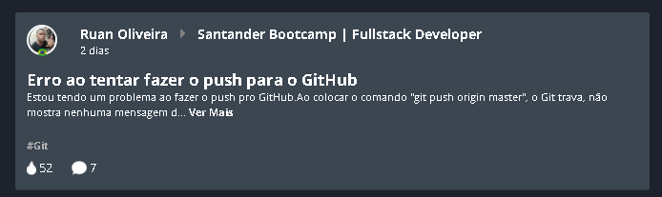

<https://web.digitalinnovation.one/topics/erro-ao-tentar-fazer-o-push-para-o-github?back=/home>

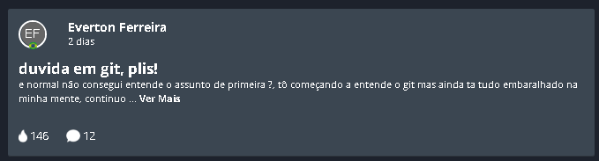

<https://web.digitalinnovation.one/articles/duvida-em-git-plis?back=/home>

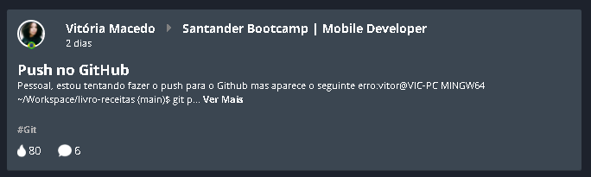

<https://web.digitalinnovation.one/topics/push-no-github?back=/home>

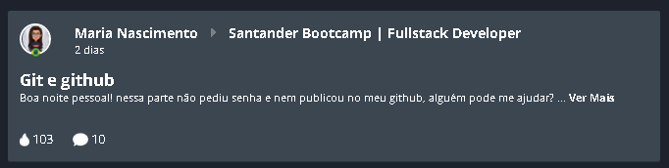

<https://web.digitalinnovation.one/topics/git-e-github-3?back=/home>

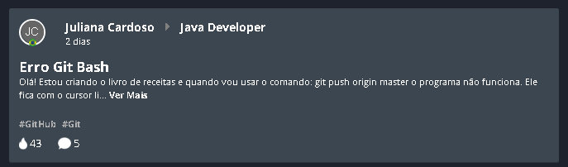

<https://web.digitalinnovation.one/topics/erro-git-bash?back=/home>

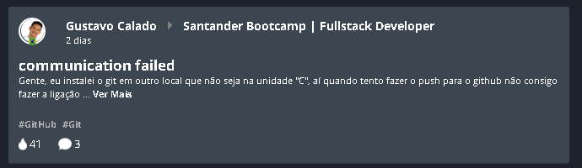

<https://web.digitalinnovation.one/topics/communication-failed?back=/home>

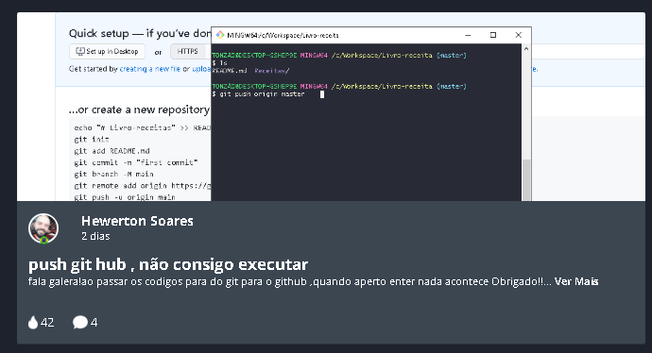

<https://web.digitalinnovation.one/articles/push-git-hub-nao-consigo-executar?back=/home>

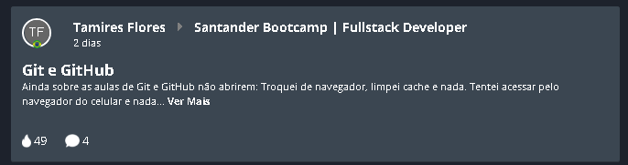

<https://web.digitalinnovation.one/topics/git-e-github-2?back=/home>

Minha solução ☺

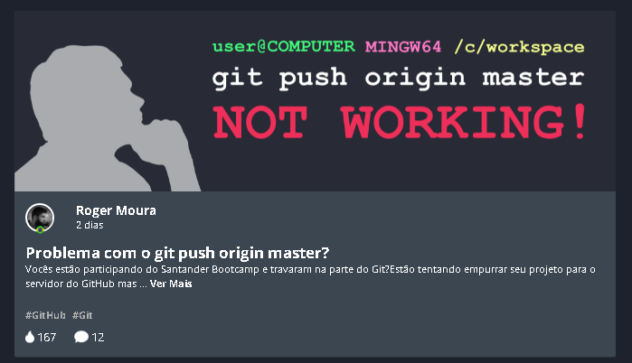

<https://web.digitalinnovation.one/articles/problema-com-o-git-push-origin-master?back=/home>

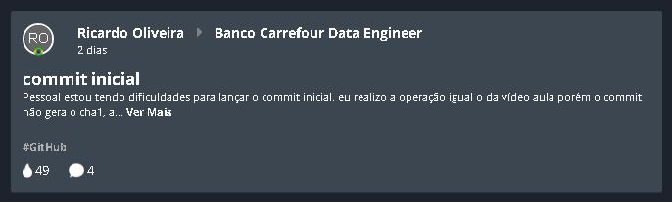

<https://web.digitalinnovation.one/topics/commit-inicial?back=/home>

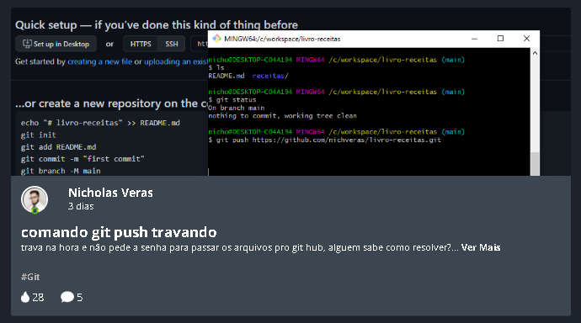

<https://web.digitalinnovation.one/articles/comando-git-push-travando?back=/home>

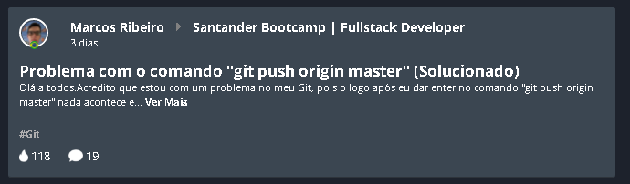

<https://web.digitalinnovation.one/topics/problema-com-o-comando-git-push-origin-master?back=/home>

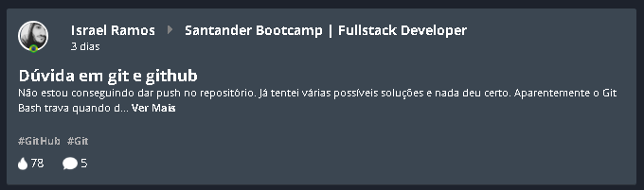

<https://web.digitalinnovation.one/topics/duvida-em-git-e-github?back=/home>

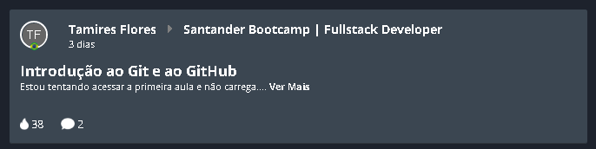

<https://web.digitalinnovation.one/topics/introducao-ao-git-e-ao-github-5?back=/home>

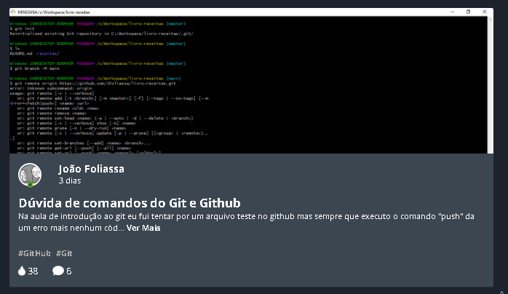

<https://web.digitalinnovation.one/articles/duvida-de-comandos-do-git-e-github?back=/home>

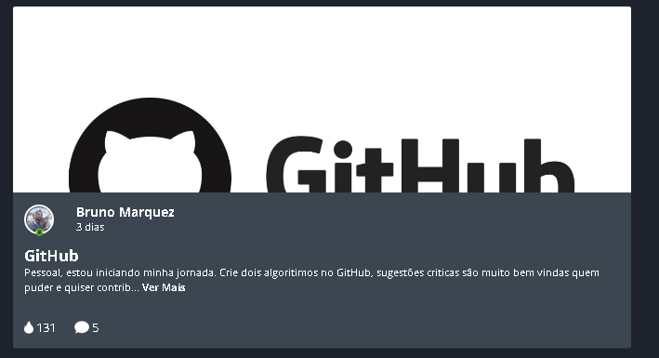

<https://web.digitalinnovation.one/articles/github?back=/home>

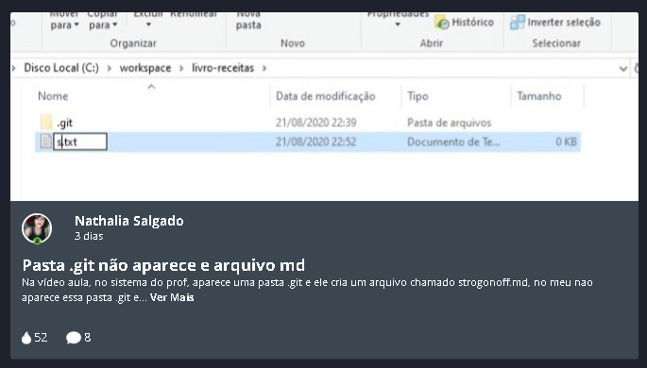

<https://web.digitalinnovation.one/articles/pasta-git-nao-aparece-e-arquivo-md?back=/home>

# Possível solução

Acredito que a melhor solução a esta enxurrada de solicitação seria a criação de uma video-aula com 4 módulos, a ser incluída no subgrupo GITHUB.

Nestas 4 aulas, serviriam para nivelar o conhecimento, pois com a chegada dos novos alunos via Bootcamp Santander, muitas pessoas tem problemas nos conhecimentos base e se perderam nas aulas do GIT.

## As aulas deveriam explorar:

1) Ambiente MS-DOS , linha de comandos e instalação do GIT

2) Configuração da integração GITHUB na tríplice fronteira: Console/Desktop/Web

3) Modulo pratico com os comandos init/global/add/push/pull etc

4) Leitura dos erros comuns e solução.

Após a criação e liberação deste modulo na plataforma, seja enviado um email da Dani a todos os alunos, convidando-os a fazer o novo modulo, servindo para demonstrar a todos, que eles nao estão sozinhos e que as dores são resolvidas ASAP.